Genes, Chromosomes and DNA
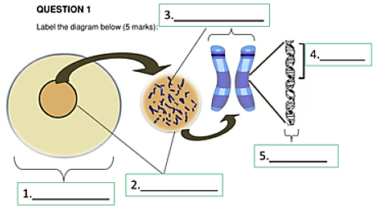
Fill in using the words: cell, gene, chromosome, DNA, nucleus. You can use the words more than once
Question 2 (WORDS TO USE - proteins, genes, A Chromosome, gene, DNA)
are a section of DNA. is arranged into sets of .
is a large chemical information database that carries the complete set of instructions for making all the ___________ a cell will ever use.
Each contains a particular set of instructions, coding for a particular protein.
WORDS TO USE - DNA, Nucleus, DNA, DNA, DNA, double helix
exists as two long, paired strands spiralled into the famous double helix. Each strand is made up of millions of chemical building blocks called bases. While there are only four different chemical bases in , the order in which the bases occur determines specific instructions for building proteins, much as specific letters of the alphabet combine to form words and sentences.
is found in the of each of the body's billions of cells. Every human cell (with the exception of mature red blood cells, which have no nucleus) contains the same . Each cell has 46 molecules of double stranded DNA. Each molecule of DNA is made up of 50 to 250 million bases housed in a .
WORDS TO USE - double helix, chromosomes, genes, sperm, gene, chromosomes, genes, genes
The in each chromosome contains many . A gene codes for a particular protein, which in turn affects the characteristics or an organism e.g. curly hair or straight hair.
A contains instructions that allow a cell to produce a specific protein such as an enzyme - that initiates one specific action. There are around 3 billion bases in all the DNA, and about 25,000 genes. ___________ make up only 1% of the chromosomes DNA. The purpose of the rest of the DNA is still being investigated.
Human cells contain two sets of , one set inherited from the mother and one from the father. All human cells, except the sex cells (gametes) contain
46 or 23 pairs. The gamete cells carry a single set of . Each set has 23 single chromosomes. In females the gametes are called ovum. In males the gametes are called .

